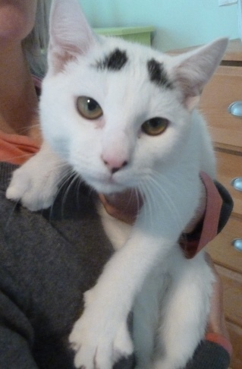
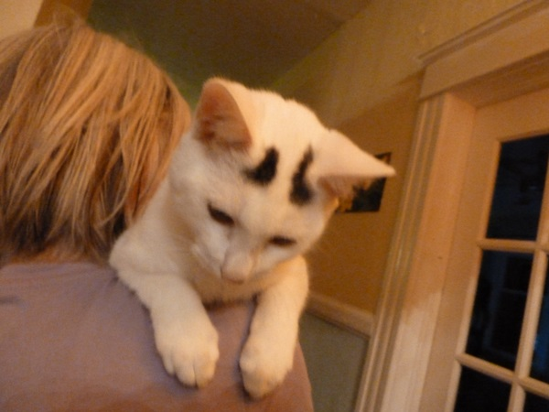
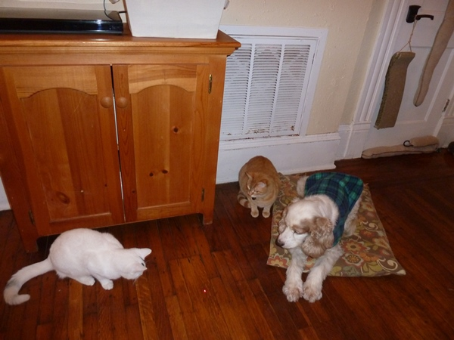

NEEDS A FOREVER HOME!
Someone left this adorable cat on the side of our road. We’ve had him for 6 weeks and have not located the owner. We are looking for someone to give him a forever home.
- Super friendly, no one is a stranger to this cat!
- He’s small in size, male, 6 lbs, vet thinks he’s 6 months old
- Has white fur all over except for 2 black spots on head & tail
- Sweet as sugar!
- Loves to sit in your lap
- Loves to be cuddled
- Loves shoulder rides
- Loves to play
- Neutered
- Gets along great with our 6 cats and dog
- Up to date on all vaccinations
from Dr. Rossi (Riverside Animal Clinic)
- Excellent with litter box; no accidents
- Perfect pet
- $40 adoption fee to offset neuter surgery.

